**DAILY ONLINE ACTIVITIES SUMMARY**

|  |  |  |  |  |  |  |  |  |
| --- | --- | --- | --- | --- | --- | --- | --- | --- |
| **Date:** | **27/05/2020** | | | | | **Name:** | **VIRESH** | |
| **Sem & Sec** | **4th SEM & ‘B’ SEC.** | | | | | **USN:** | **4AL18CS097** | |
| **Online Test Summary** | | | | | | | | |
| **Subject** | | **Object Oriented Concepts** | | | | | | |
| **Max. Marks** | | **30** | | **Score** | | | **28** | |
| **Certification Course Summary** | | | | | | | | |
| **Course** | **Python for Machine Learning** | | | | | | | |
| **Certificate Provider** | | | **Greatlearning Academy** | | **Duration** | | | **5.0 Hrs.** |
| **Coding Challenges** | | | | | | | | |
| **Problem Statement 1:** Write a C Program to sort an array of integers in ascending order  and display the sorted array and Number of passes performed for sorting.  **Problem Statement 2:** Given an array arr[ ] of the positive integers of size N, the task is to  find the largest element on the left side of each index which is smaller than the element  present at that index. Note: If no such element is found then print -1. | | | | | | | | |
| **Status: Done** | | | | | | | | |
| **Uploaded the report in Github** | | | | | **Yes** | | | |
| **If yes Repository name** | | | | | **Lockdown-Coding**  <https://github.com/viresh-kulal/Lockdown-Coding/blob/master/triangularnumbers.c> | | | |
| **Uploaded the report in slack** | | | | | **Yes** | | | |

**Online Test Summary: Today 18CS45 test was scheduled from 09:15 am to 09:45am .The portion for the IA was 5th module there were 30 questions and the time assigned was 30 minutes and the questions were MCQ type.**

**The snapshot of the completion of the test and the marks allotted is attached here.**

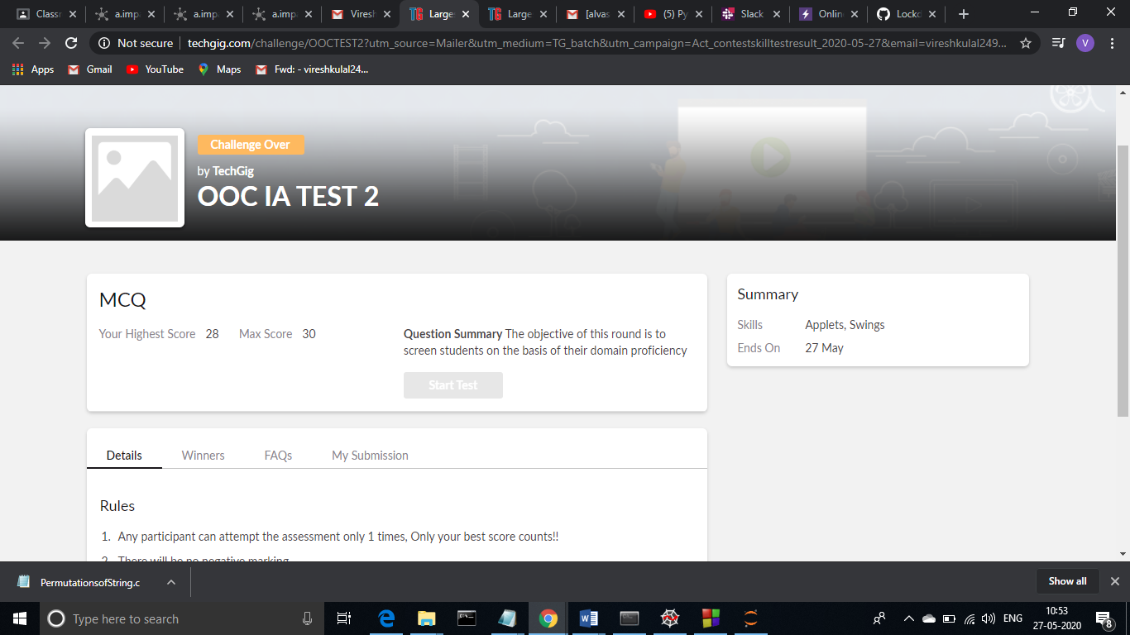

**Online Certification Course Summary: In today’s session, I have continued the course with pandas combining dataframes and functions inside the dataframes in that merge and join function and then I came to know about that what exactly means that concepts and their examples**

**The snapshots of today’s session is attached below.**

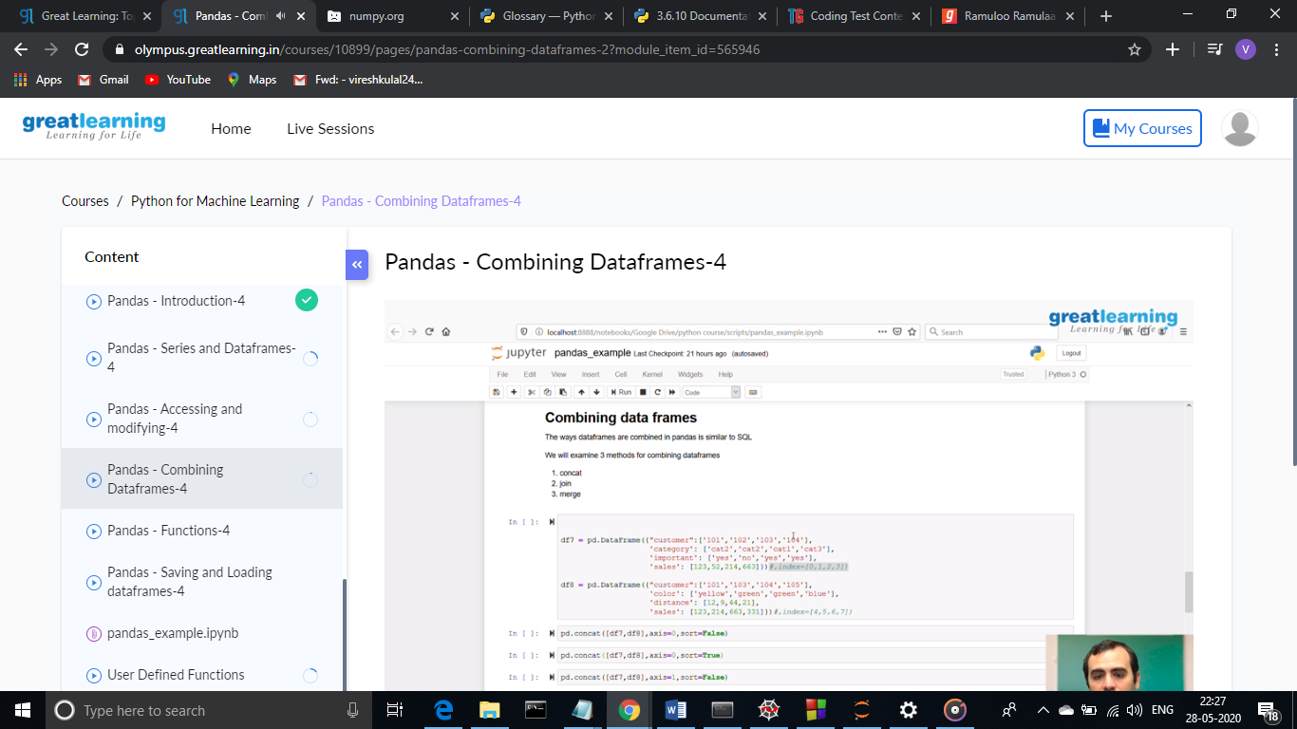 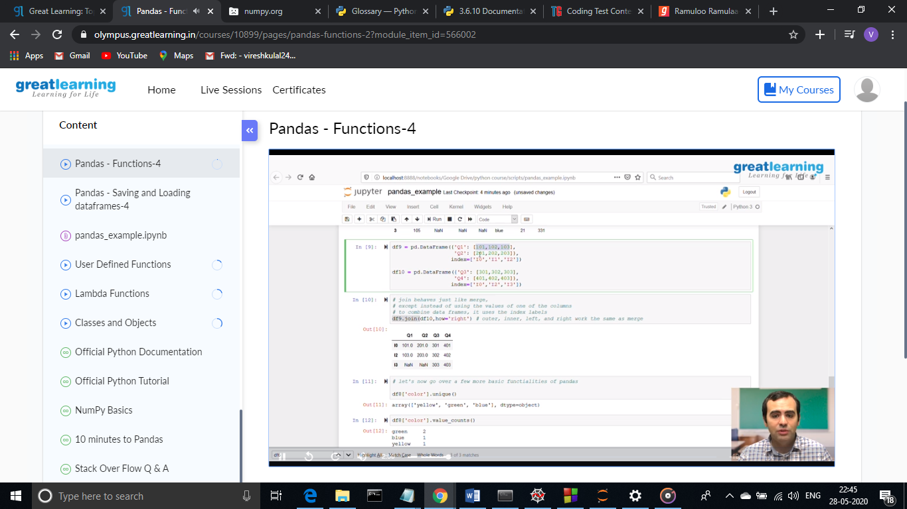

**Online Coding Summary: Today I had received one program from prof.Venkatesh CSE Dept. The programs is mentioned above(pg.01). I have uploaded it to my Github repository.**

The Repository Link is: <https://github.com/viresh-kulal/Lockdown-Coding>

And the snapshots of the programs sort.c and array.cpp are attached below.

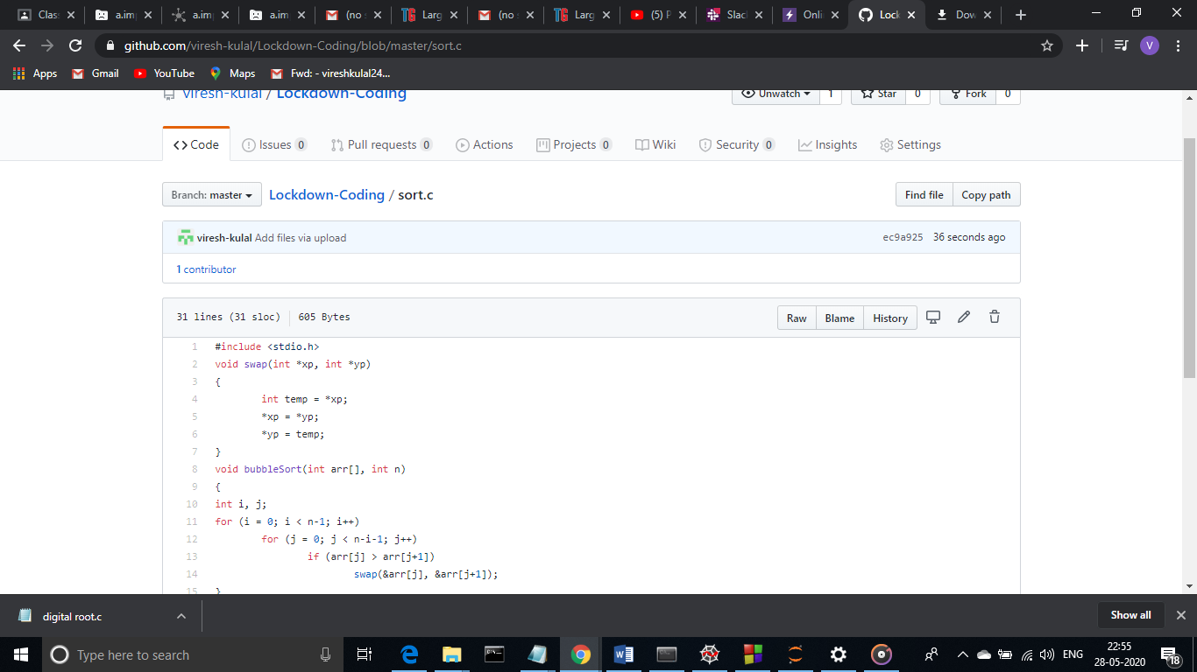 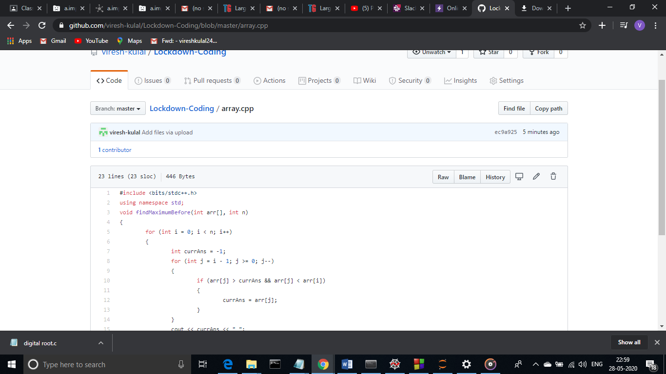

**Thank you.**